**CARBON, ACTIVATED**

**HERO**

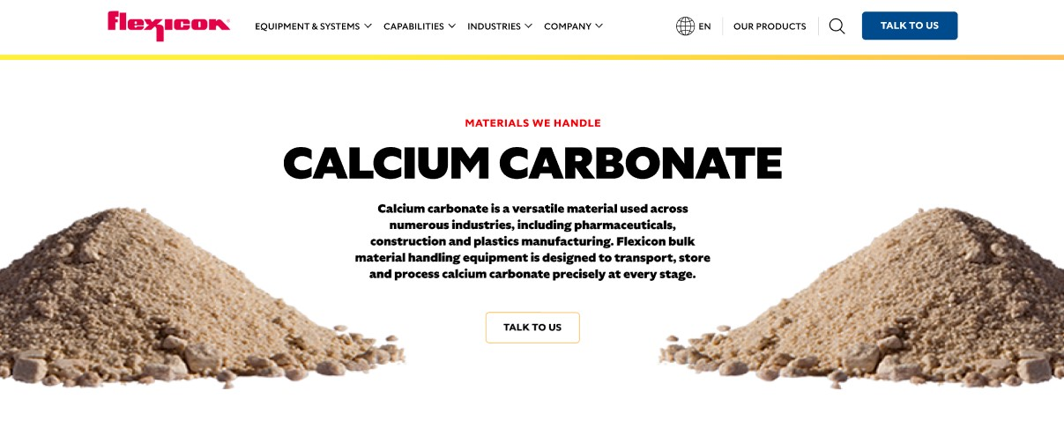

Activated Carbon is a powerful absorbent used across industries for purification, filtration, and recovery processes. Flexicon bulk material handling equipment ensures safe, efficient, and dust-controlled movement of carbon, activated.

**Button**: Talk To Us

**SHELF #1 - PRODUCT DESCRIPTION**

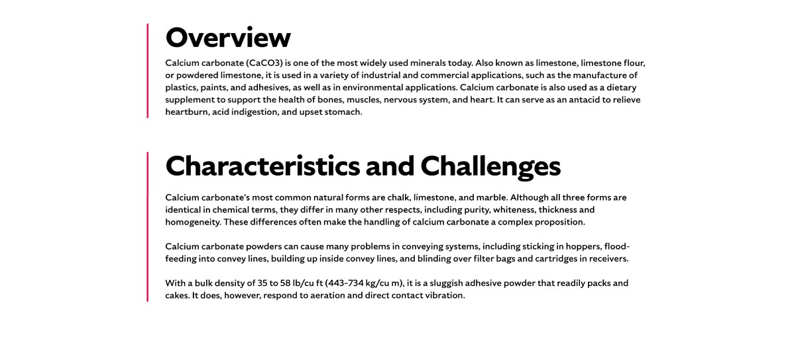

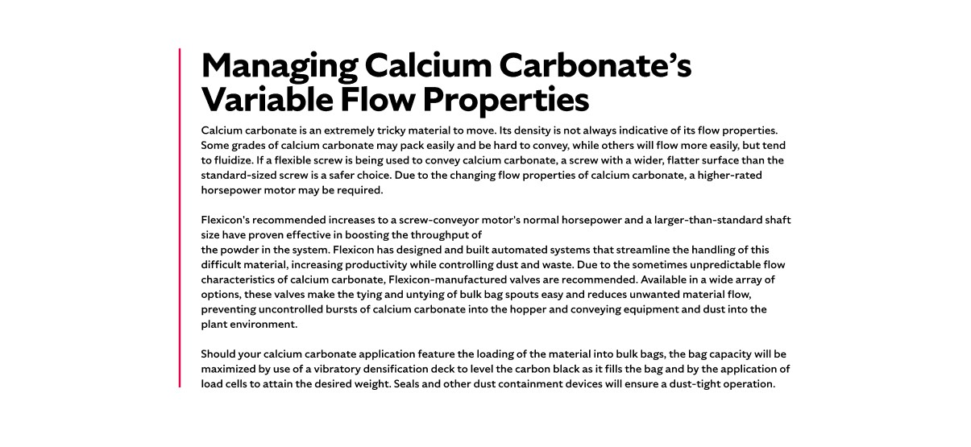

**Overview**

Activated carbons are produced by heating organic materials such as coal, wood, or fruit pits to high temperatures, creating a porous structure with exceptional surface area. This makes it ideal for capturing contaminants in applications ranging from water treatment and air purification to gold recovery and medical filtration. Available in powered (PAC), granulated (GAC), and pellet forms, carbon activated is selected based on pore size and application needs. Its versatility

**Characteristics and Challenges**

Activated carbon is extremely fine in powdered form, with an average particle size of just 20 microns and a low bulk density. It is highly aeratable, meaning even slight air movement can cause it to become airborne and settle as dust, coating surfaces and equipment. Some grades are flammable and may spontaneously ignite when exposed to air or moisture.

Activated carbon can fluidize and flood conveying lines, especially in powdered form. It also resists flow in granular form and may pose explosion risks, making dust control and safe handling essential.

**SHELF #2 - FLEXICON SOLUTIONS**

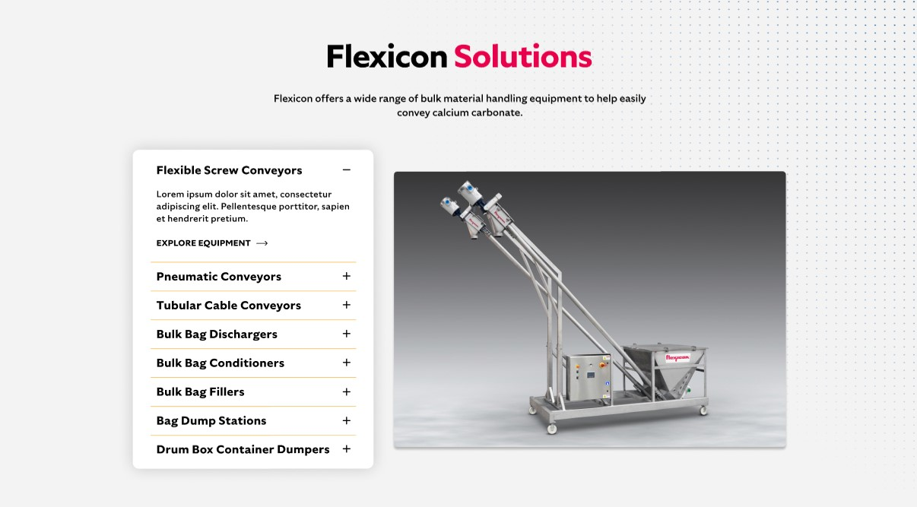

**Flexicon Solutions**

Flexicon offers a wide range of bulk material handling equipment to help easily convey calcium carbonate.

* **Flexible Screw Conveyor**: Reliably transport activated carbon powders that tend to fluidize or compact, while minimizing degradation and dust.
* **Pneumatic Conveyors**: Maintain clean, efficient transfer of activated carbon through enclosed systems that capture and recycle dust.
* **Tubular Cable Conveyors**: Offer enclosed, low-impact conveying ideal for preserving the integrity of activated carbon in space-constrained layouts.
* **Bulk Bag Dischargers**: Provide secure, dust-tight unloading of activated carbon from bulk bags into downstream equipment with minimal operator exposure.
* **Bulk Bag Conditioners**: Break up hardened activated carbon inside bulk bags to promote smooth, uninterrupted flow during discharge.
* **Bulk Bag Fillers**: Accurately fill bulk bags with activated carbon using vibration decks and sealing systems to reduce dust and ensure weight precision.
* **Bag Dump Stations**: Enable safe manual dumping of activated carbon with integrated filtration and dust control for cleaner operations.
* **Drum Box Container Dumpers**: Safely empty activated carbon from smaller containers into processing systems while reducing manual handling and airborne particles.

**SHELF #3: LIFETIME PERFORMANCE GUARANTEE**

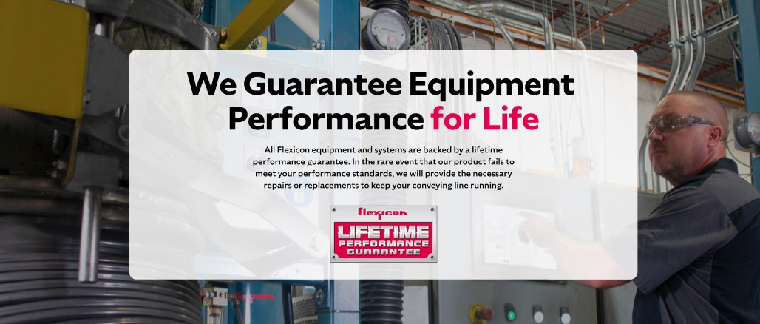

**Lifetime Performance Guarantee**

All Flexicon equipment and systems are backed by a lifetime performance guarantee. In the rare event that our product fails to meet your performance standards, we will provide the necessary repairs or replacements to keep your conveying line running.

**SHELF #4: CASE STUDIES**

